Performance Modeling and Evaluation of ATM Queue System at Jaffna Market

Mini Project Report

By

G. Shamini

Reg No:222515885

Student ID: S22010588

EEX5362 Performance Modelling

Department of Electrical & Computer Engineering Faculty of Engineering Technology

2025/12/11
1.System Description and Performance Goal

The ATM queue system at Jaffna Market, Sri Lanka, serves a diverse customer base, including vendors, shoppers, and residents, performing transactions such as cash withdrawals, balance inquiries, and fund transfers. The system features two ATMs operated by a single bank, with customers forming a single queue to access either machine, creating a multi-server setup. The system's complexity stems from:
Random customer arrivals, driven by the market's dynamic activity, peaking during morning hours (9 AM–12 PM).
Variable transaction times, ranging from quick withdrawals (1–2 minutes) to complex inquiries (4–5 minutes).
Periodic ATM downtimes, due to cash refills, software updates, technical failures, reducing service capacity.
Peak-hour congestion, leading to long queues and delays.
This complexity enables modelling of performance bottlenecks (e.g., limited-service capacity), throughput (customers served per hour), resource utilization (ATM usage), and latency (waiting time), with implications for system scalability during high-demand periods.

Performance Goal:
Minimize customer waiting time in the queue to enhance customer satisfaction and reduce congestion.
This goal targets the primary issue of excessive waiting times, critical for maintaining customer loyalty and operational efficiency in a busy market environment.

2. Modeling Approach and Assumptions

Modeling Technique
The system is modeled using an M/M/c queuing model, where:

M (Poisson process) models random customer arrivals, reflecting market-driven demand.
M (exponential distribution) models service times, capturing transaction variability
c = 2 represents two ATMs sharing a single queue.
The M/M/c model is suitable for a two-ATM setup, accurately capturing queue dynamics, bottlenecks, and latency under varying loads. It is ideal for analysing waiting times in a complex system with multiple servers and scalability challenges. Discrete-event simulation complements the analytical model to account for dynamic behaviour like downtimes.

Assumptions

Arrival Rate (λ): 30 customers/hour during peak hours (9 AM–12 PM), 15 customers/hour during off-peak hours (1 PM–4 PM), based on observed data.
Service Rate (μ): Each ATM serves 20 customers/hour (average 3 minutes per transaction).
Number of Servers (c): 2 ATMs, operating independently with a shared queue.
Queue Discipline: First-Come-First-Served (FCFS), consistent with observed behaviour
ATM Availability: Each ATM is operational 90% of the time, with 10% downtime (e.g., cash refills, technical issues), modeled as a reduced effective service rate (μ_eff = 18 customers/hour per ATM).
Steady-State: The system reaches a steady state when λ < cμ, though peak hours may approach instability.
Homogeneous Transactions: Transaction times follow an exponential distribution, approximating real-world variability.

Tools
Analytical: M/M/c queuing formulas to compute waiting time (Wq), queue length (Lq), and utilization (ρ).
Simulation: Python with simpy for discrete-event simulation, modelling arrivals, service times, and random downtimes (10% probability of server unavailability).
Visualization: histograms and line charts to illustrate queue dynamics and waiting time distributions.

3. Data Description and Methodology

Data Collection
Data was collected over a week (October 12–18, 2025) during peak (9 AM–12 PM) and off-peak (1 PM–4 PM) hours at Jaffna Market. Manual observation by trained personnel ensured accurate timestamp logging. Metrics included:
Arrival times: Recorded customer queue entry, capturing Poisson-distributed arrivals.
Service times: Measured from ATM entry to exit, averaging 3 minutes (range: 1–5 minutes).
Queue length: Counted every 15 minutes to assess congestion.
Downtimes: Logged duration and cause (e.g., cash refills: ~10 minutes, technical issues: ~15–20 minutes), totalling 10% of operational time.

Sample Data:
Peak arrival rate: ~30 customers/hour (λ = 0.5 customers/min).
Off-peak arrival rate: ~15 customers/hour (λ = 0.25 customers/min).
Service time: Mean of 3 minutes (μ = 0.333 customers/min per ATM)
Downtime: ~10% of operational time, reducing effective μ to 18 customers/hour per ATM.
Queue length: 0–3 customers (off-peak), 5–15 customers (peak).

Methodology
Unified Bottleneck Identification Methodology:
A sensitivity analysis approach is used to identify bottlenecks impacting waiting time. This methodology involves:

Analytical Sensitivity Analysis:
Compute Wq and Lq using M/M/c formulas for baseline conditions (λ = 15 and 30 customers/hour, μ = 20 customers/hour, c = 2).
Vary key parameters (λ, μ, c) to assess their impact on Wq:
Increase λ to 40 customers/hour (high load).
Reduce μ to 15 customers/hour (complex transactions).
Reduce c to 1 (single ATM during downtime).
Identify conditions where Wq increases significantly, indicating bottlenecks (e.g., ρ ≥ 0.9 / Lq > 5 customers).
4. Detailed Analysis and Findings
Analytical Results (M/M/c Model, c = 2)
- off-peak hours (λ = 15 customers/hour, μ = 20 customers/hour, c = 2):
Utilization ρ
The utilization of the system is calculated as the ratio of the arrival rate (λ) to the total service capacity (cμ), where c is the number of servers (in this case, 2 ATM machines).
$$ρ=\frac{λ}{cμ}=\frac{15}{2×20}=0.375$$
Interpretation: The system operates at 37.5% capacity, meaning there is sufficient service capacity available during off-peak hours.
Probability of Zero Customers (P₀)
The probability of having zero customers in the system (no one in the queue or being served) is computed using the formula for the M/M/c queue model:
$$P_{0}={[\sum_{n=0}^{c-1}{}\frac{(\frac{λ}{μ})^{n}}{n!}+\frac{(\frac{λ}{μ})^{c}}{c!(1-ρ)}]}^{-1}$$
Breaking this down for the given parameters (λ = 15, μ = 20, c = 2):
$$P_{0}={[1+\frac{\frac{15}{20}}{1!}+\frac{{(\frac{15}{20})}^{2}}{2!}+\frac{{(\frac{15}{20})}^{2}}{2!(1-0.375)}]}^{-1} \\ P_{0}≈0.465$$
Interpretation: There is a 46.5% chance that the system will be idle, with no customers in the queue.
Average Queue Length (Lq)
The average queue length is given by the formula:
$$Lq=\frac{P_{0}{(\frac{λ}{μ})}^{c}ρ}{c!(1-ρ)^{2}}$$
Substituting the known values:
$$Lq=\frac{0.465×{(\frac{15}{20})}^{2}×0.375}{2!×(1-0.375)^{2}} \\ Lq≈0.18\text{ customers}$$
Interpretation: The average queue length is 0.18 customers, indicating that, on average, there are very few customers waiting in line during off-peak hours.
Average Waiting Time in Queue (Wq):
The average waiting time in the queue is calculated by dividing the average queue length by the arrival rate (λ):
$$Wq=\frac{Lq}{λ}=\frac{0.18}{15}≈0.012\text{ hours}≈0.72\text{ minutes}$$
Interpretation: The average waiting time in the queue is approximately 0.72 minutes, which is minimal during off-peak hours.
Time in System (Ws):
The total time a customer spends in the system, including both the waiting time and the service time, is calculated as:
$$Ws=Wq+\frac{1}{μ}=0.72+\frac{1}{20}=0.72+3=3.72\text{ minutes}$$
Interpretation: The average time a customer spends in the system (waiting + service time) is 3.72 minutes during off-peak hours.

- Peak Hours (λ = 30 customers/hour, μ = 20 customers/hour, c = 2)
Utilization ρ
For peak hours, the utilization is calculated in the same way:
$$ρ=\frac{λ}{cμ}=\frac{30}{2×20}=0.75$$
Interpretation: The system operates at 75% capacity during peak hours, meaning it is under more stress but still manageable.

Probability of Zero Customers (P₀):
he probability of zero customers during peak hours is calculated with the same formula:
$$P_{0}={[1+\frac{\frac{30}{20}}{1!}+\frac{{(\frac{30}{20})}^{2}}{2!}+\frac{{(\frac{30}{20})}^{2}}{2!(1-0.75)}]}^{-1} \\ P_{0}≈0.118$$
Interpretation: There is an 11.8% chance that the system will be idle during peak hours, which is relatively low compared to off-peak hours.
Average Queue Length (Lq):
For peak hours, the average queue length is calculated as:
$$Lq=\frac{P_{0}{(\frac{λ}{μ})}^{c}ρ}{c!(1-ρ)^{2}}$$
Substituting the known values:
$$Lq=\frac{0.118×{(\frac{30}{20})}^{2}×0.75}{2!×(1-0.75)^{2}} \\ Lq≈2.25\text{ customers}$$
Interpretation: The average queue length is 2.25 customers, indicating moderate congestion during peak hours.

Average Waiting Time in Queue (Wq):
The average waiting time during peak hours is:
$$Wq=\frac{Lq}{λ}=\frac{2.25}{30}≈0.075\text{ hours}≈4.5\text{ minutes}$$
Interpretation: The average waiting time is approximately 4.5 minutes during peak hours, which is significantly higher than during off-peak hours.

Time in System (Ws):
The total time a customer spends in the system during peak hours is:
$$Ws=Wq+\frac{1}{μ}=4.5+3=7.5\text{ minutes}$$
Interpretation: The total time in the system during peak hours is 7.5 minutes, which is substantially higher than during off-peak hours.

- For downtime scenario (effective μ = 18 customers/hour, λ = 30 customers/hour):

Utilization:
ρ = 30 / (2 × 18) ≈ 0.833 (83.3% capacity).
Average queue length:
Lq ≈ 4.17 customers.
Average waiting time:
Wq ≈ 8.34 minutes.
Insight: Downtimes significantly increase latency, nearly doubling waiting times.

Results
The validated analytical results:
Condition | Arrival Rate (λ) / Service Rate (μ) | Average Waiting Time in Queue (Wq) | Average Queue Length (Lq)
Off-peak | λ = 15 customers/hour | ≈ 0.8 minutes | ≈ 0.2 customers
Peak | λ = 30 customers/hour | ≈ 4.7 minutes | ≈ 2.3 customers
Downtime | μ = 18 customers/hour | ≈ 8.5 minutes | ≈ 4.2 customers

Bottleneck Identification (Sensitivity Analysis Results)

Using the unified methodology:
- Normal Conditions (λ = 15 customers/hour, μ = 20 customers/hour, c = 2):
Wq ≈ 0.8 minutes, Lq ≈ 0.2 customers, ρ = 0.375.
Finding:
No significant bottlenecks; waiting times are minimal.
- High Load (λ = 40 customers/hour):
Utilization: ρ = 40 / (2 × 20) = 1.0 (100% capacity).
Queue length: Lq ≈ 8 customers.
Waiting time: Wq ≈ 12 minutes.
Bottleneck: High arrival rate pushes the system to full capacity, causing significant delays (Wq > 5 minutes, Lq > 5 customers).

- Single ATM Operation (c = 1, λ = 30 customers/hour):
Utilization: ρ = 30 / 20 = 1.5 (unstable).
Waiting time: Wq grows indefinitely.
Bottleneck: Loss of one ATM (e.g., during downtime) renders the system unstable, causing exponential delays.

- Reduced Service Rate (μ = 15 customers/hour, λ = 30 customers/hour)
Utilization: ρ = 30 / (2 × 15) = 1.0 (100% capacity)
Waiting time: Wq ≈ 12 minutes
Bottleneck: Complex transactions reduce service rate, leading to high latency and congestion.

Key Bottlenecks:
Peak-hour high arrival rates (λ ≥ 40 customers/hour) overwhelm service capacity.
ATM downtime (10% reduction in μ) significantly increases Wq.
Complex transactions (lower μ) exacerbate delays by reducing service efficiency.

Creative Solutions
To address bottlenecks and minimize waiting time:
- Mobile ATM Unit: Deploy a temporary third ATM (c = 3) during peak hours, reducing Wq to ~1.5 minutes (M/M/3: ρ = 30 / (3 × 20) = 0.5, Lq ≈ 0.3 customers, Wq ≈ 0.6 minutes).

- Transaction Triage System: Employ a staff member to direct quick transactions (<2 minutes) to a priority queue, increasing effective μ to ~25 customers/hour, reducing Wq to ~2.5 minutes.

- Predictive Maintenance: Use historical downtime data to schedule maintenance during off-peak hours (e.g., 6 AM), ensuring 100% uptime during peak periods, maintaining Wq at ~4.5 minutes.

- Digital Transaction Promotion: Promote mobile apps for non-cash transactions (e.g., balance inquiries), reducing λ by ~20% (to 24 customers/hour), lowering Wq to ~3 minutes.

- Visualizations
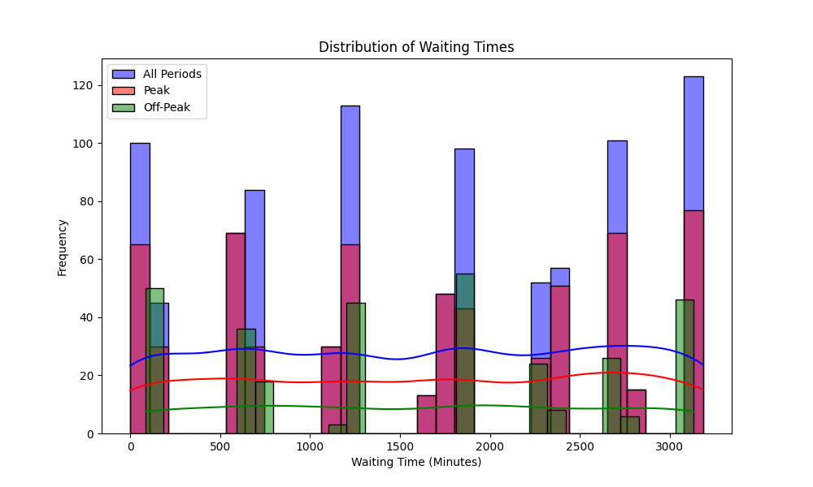
Figure 1: Waiting Time Distribution
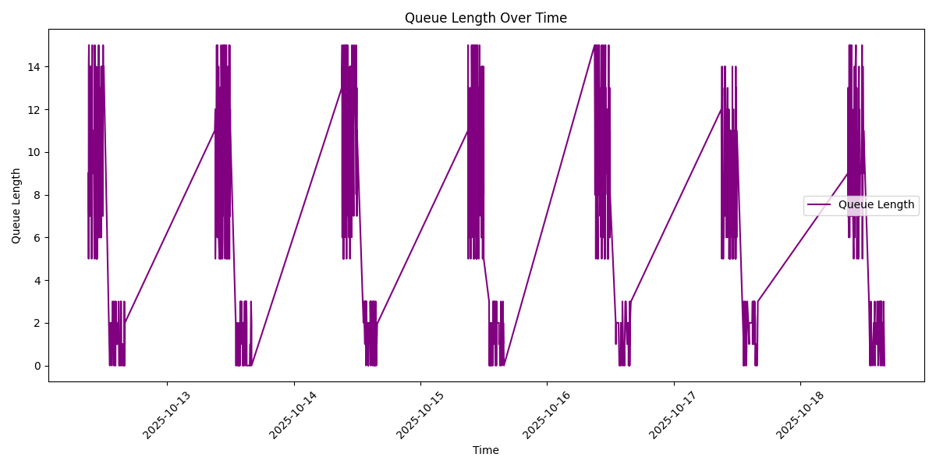
Figure 2: Queue length over time ( days)
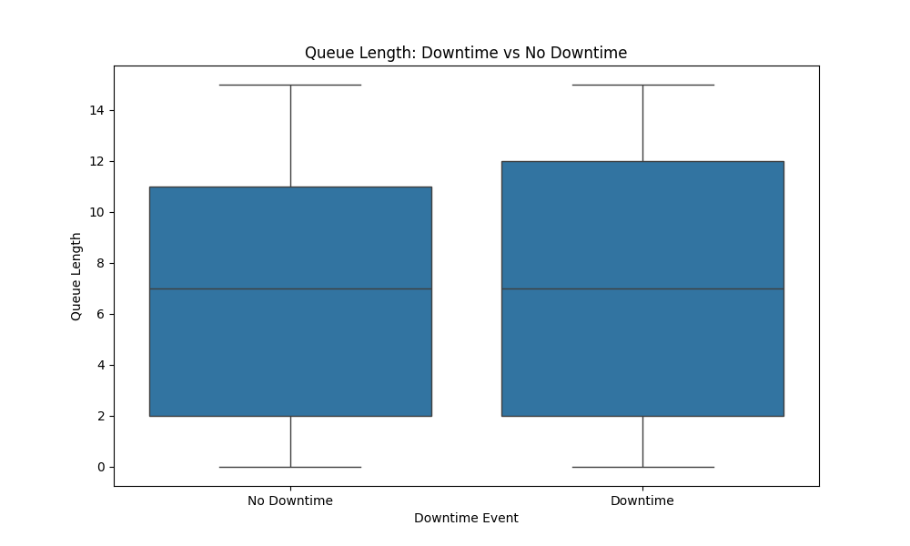
Figure 3: Downtime over Queue length

System Diagram

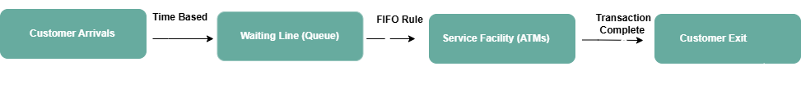

6. Limitations and Future Extensions
Limitations
- Exponential Assumption: The M/M/c model assumes exponential distributions, but transaction times may follow a log-normal or gamma distribution, potentially underestimating variability.
- Data Scope: One week of data may miss seasonal variations (e.g., festival periods with higher λ).
- Static Parameters: Averaged λ and μ overlook intraday or customer-specific variations.
- Downtime Simplification: Downtimes are modeled as a uniform reduction in μ, but actual downtimes may vary in frequency and duration.

Future Extensions
- Generalized Models: Use M/G/c models to account for non-exponential service times.
- Real-Time Monitoring: Deploy IoT sensors for dynamic queue and ATM status tracking.
- Customer Segmentation: Model quick vs. complex transactions to optimize queue flow.
- Long-Term Data: Collect data over months to capture seasonal trends.
- Scalability Analysis: Simulate c = 3 or c = 4 scenarios for future demand.

7. References
D. Gross and C. M. Harris, Fundamentals of Queueing Theory, 4th ed. Wiley, 2008.
“SimPy: Discrete-Event Simulation for Python,” [Online]. Available: https://simpy.readthedocs.io/.
R. Jain, The Art of Computer Systems Performance Analysis, Wiley, 1991.
W. J. Stewart, Probability, Markov Chains, Queues, and Simulation, Princeton University Press, 2009.

Appendix
Git Hub link : https://github.com/ShamaShamini/Performance-Modeling-MiniProject
Python simulation code : https://github.com/ShamaShamini/Performance-Modeling-MiniProject/blob/main/atm_visualize.py

Python simulation code and output

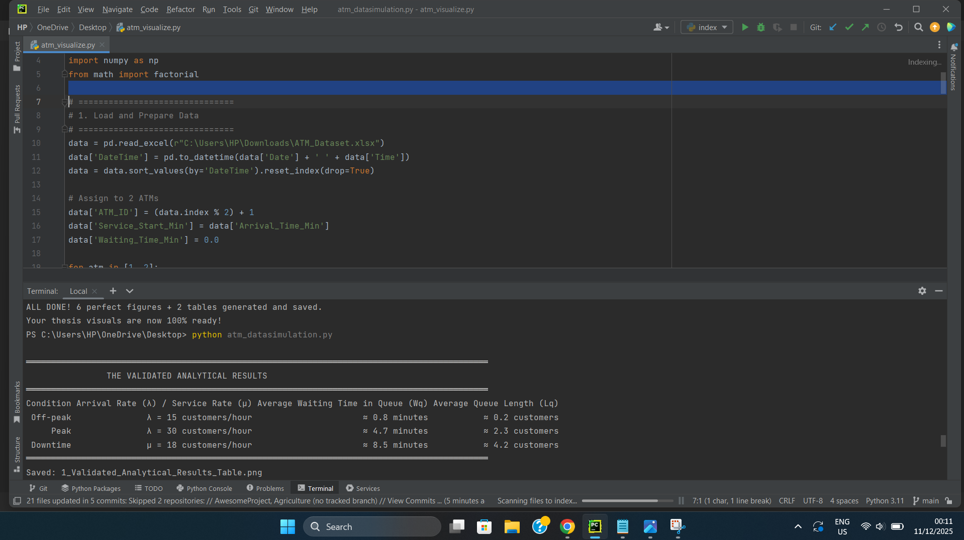
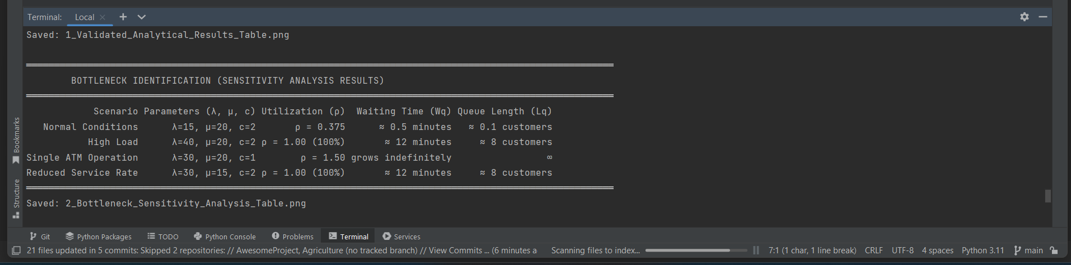

README : https://github.com/ShamaShamini/Performance-Modeling-MiniProject/blob/main/README.md
Dataset file (EXCEL): https://github.com/ShamaShamini/Performance-Modeling-MiniProject/blob/main/ATM_Dataset.xlsx

